Section of solids:

A1. A pentagonal pyramid of base side 30 mm and axis length 80mm is resting on HP  on its base with one of its base side parallel to VP. It is cut by a plane inclined at 30° to HP and perpendicular to VP and is bisecting the axis. Draw its front view, sectional top view, and the true shape of section

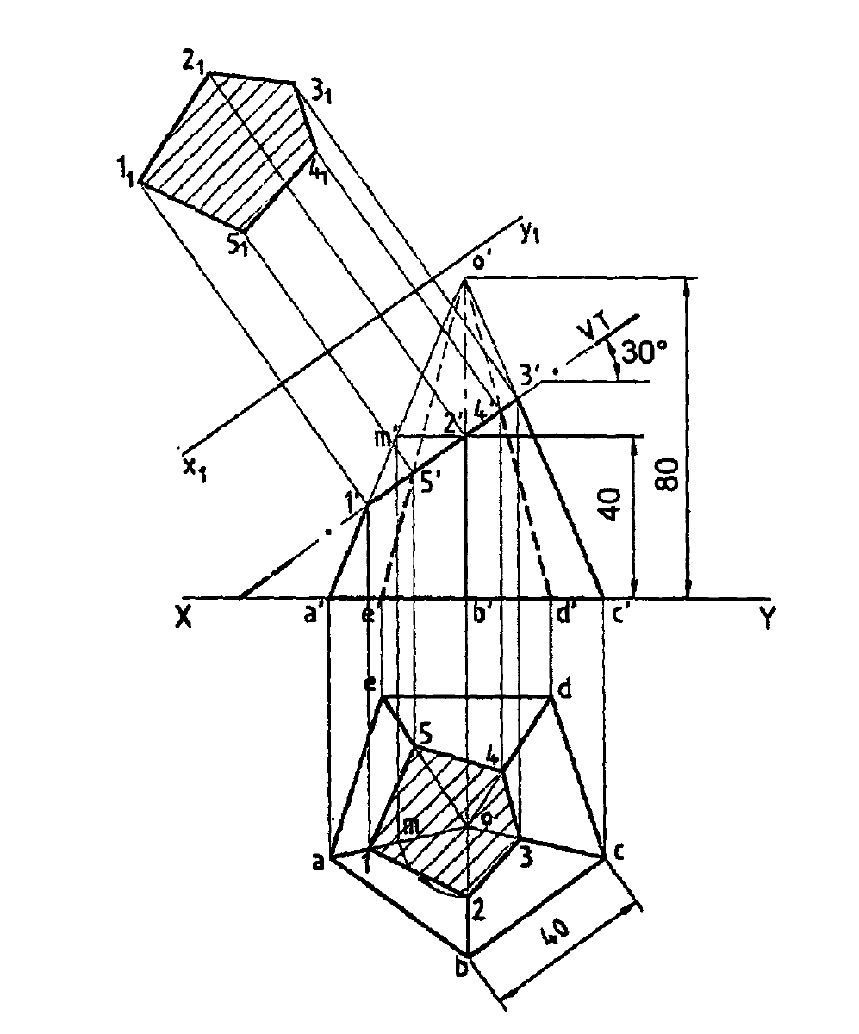

Intersection of solids:

A2.A vertical cylinder of diameter 120 mm is fully penetrated by a cylinder of diameter 90 mm, their axes intersecting each other. The axis of the penetrating cylinder is inclined at 300 to the HP and is parallel to the VP. Draw the top and front views of the cylinders and the curves of intersection lines are at right angles.

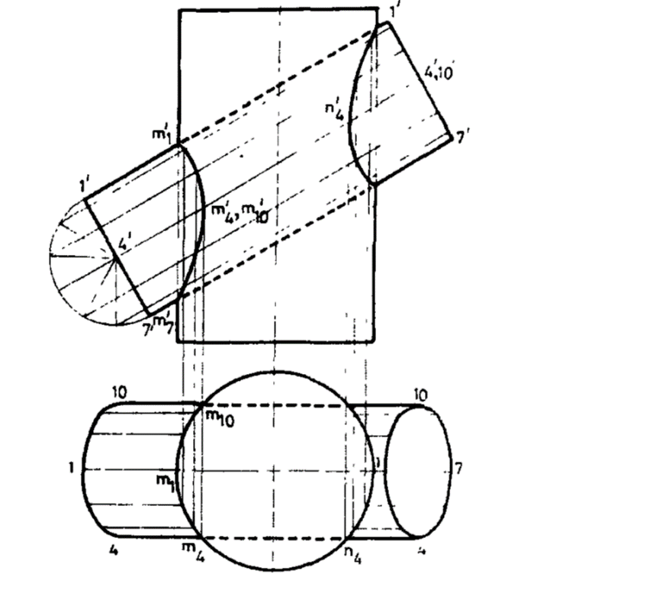

Orthographic projection of objects:

A3. Draw the orthographic projection of the object given below:

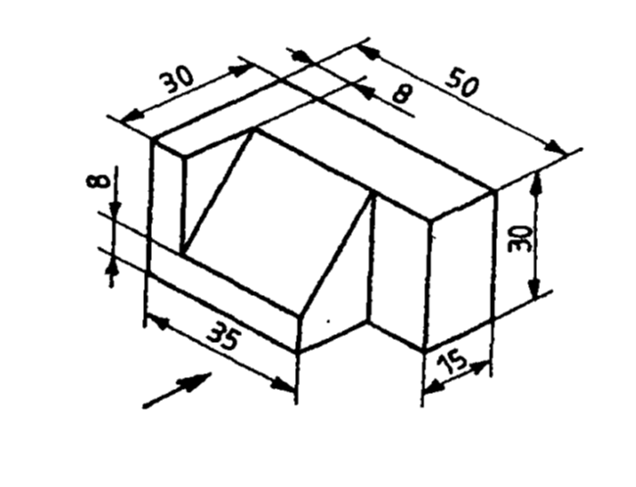

Solution:

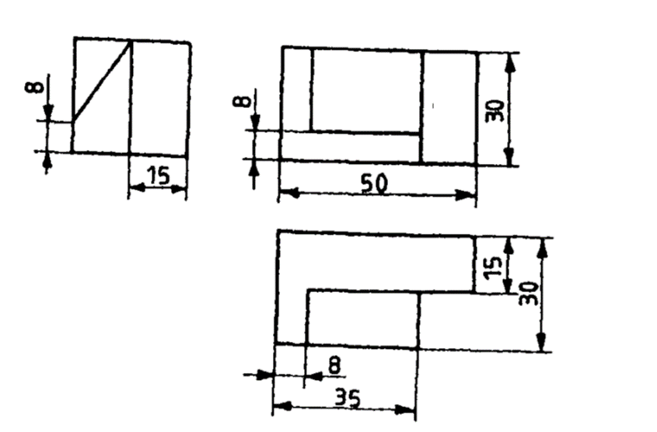

A4. Draw  the Orthographic projections ( elevation, plan and side view) for  Isometric view of the object given below

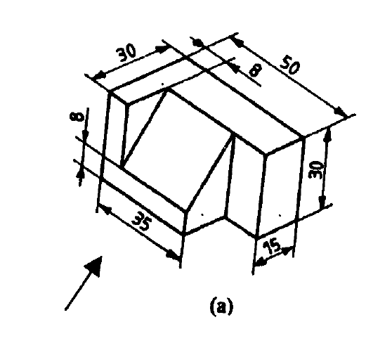

Solution: 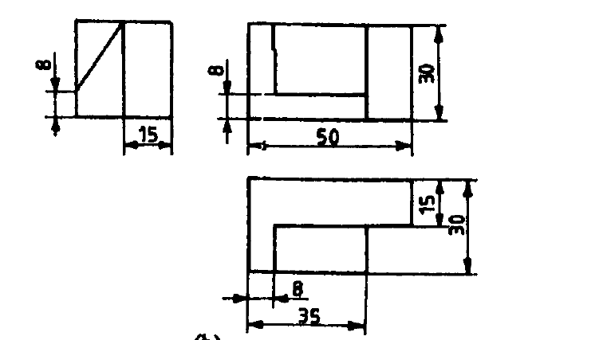

Isometric view of objects:

A5. Problem: A right circular cone of base diameter 60mm and height 75mm is cut by a plane making an angle of 300 with the horizontal. The plane passes through the mid point of the axis. Draw isometric view of the truncated solid

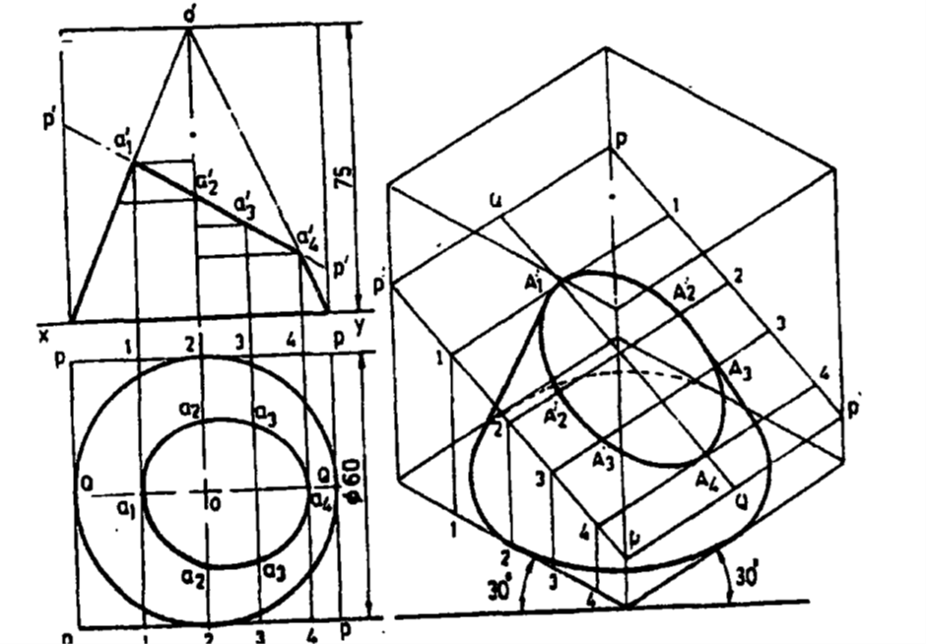

A6. 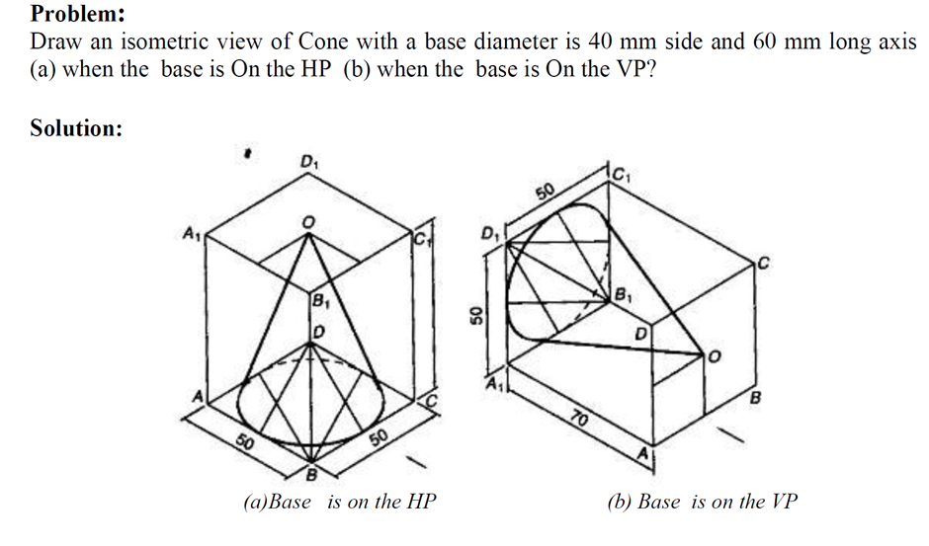

Development of surfaces:

A7.  Fig  below shows a rectangular scoop with dimensions for lap-seam, Draw the development of the above scoop with dimensions

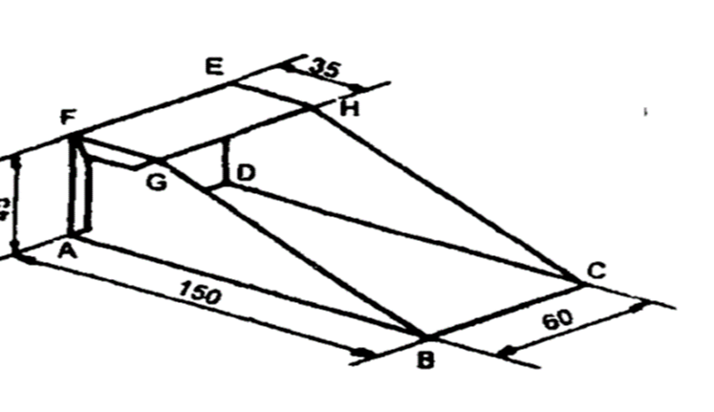

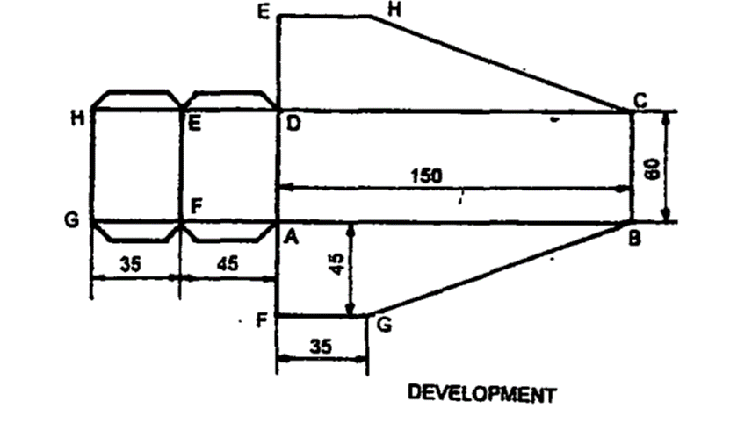

A8. A pentagonal pyramid, side of base 50 mm and height 80 mm rests on its base on the ground with one of its base sides parallel to V.P. A section plane perpendicular to VP and inclined at 30° to H.P cuts the pyramid, bisecting its axis. Draw the development of the truncated pyramid

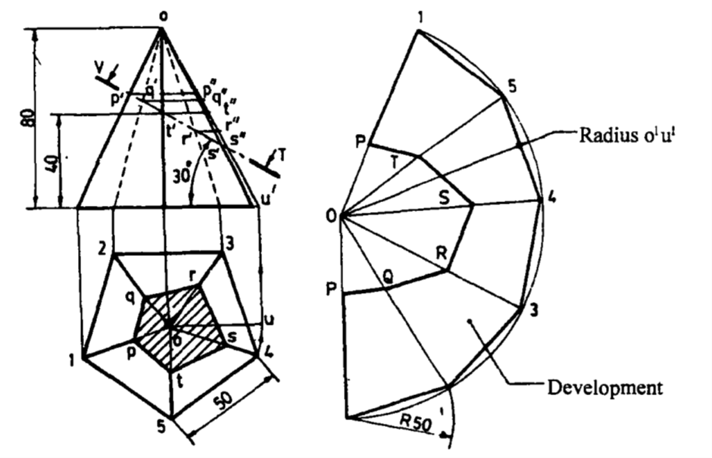

Section of solids:

B1. A square pyramid base 40mm side and axis 65mm long has its base on HP and all the edges of the base are equally inclined to VP. It is cut by a section plane erpendicular to VP and inclined at 45⁰ to HP and bisecting the axis. Draw its sectional plan, sectional end elevation and true shape of the section.

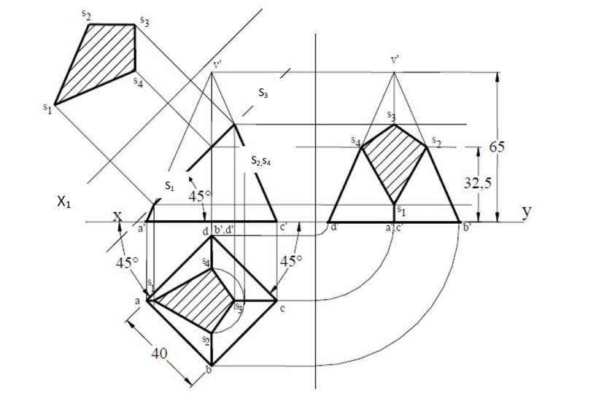

Intersection of solids:

B2. A cylinder of diameter 45 mm penetrates fully into a cone of base diameter 75 mm and altitude 100 mm resting on its base on H.P. The axis of cylinder intersects the axis of the cone at right angles at a distance of 25 mm above the base of the cone. The axis of the cylinder is parallel to both the H.P and V.P. Draw the curves of intersection of the solid.

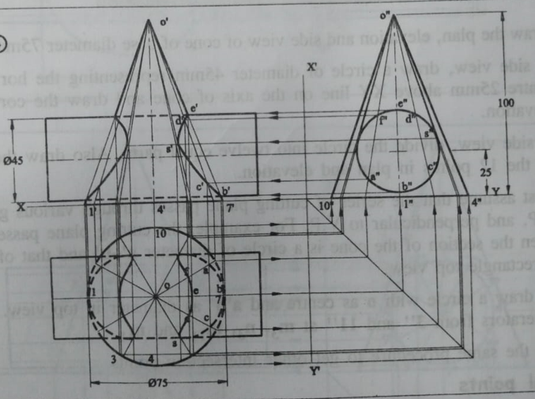

Orthographic projection of objects:

B3. Draw the first-angle orthographic projections (three orthographic views) of the given object

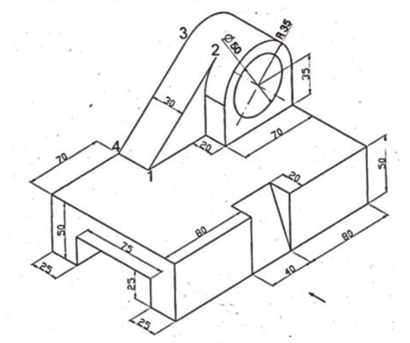

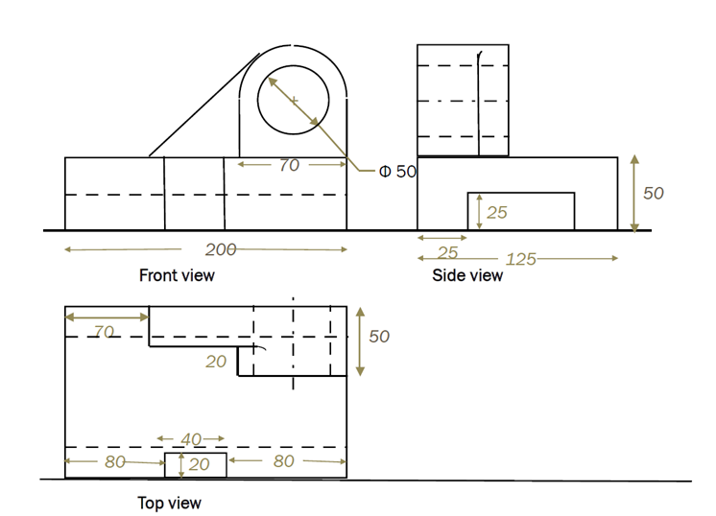

B4. Draw the three orthographic views of the given object

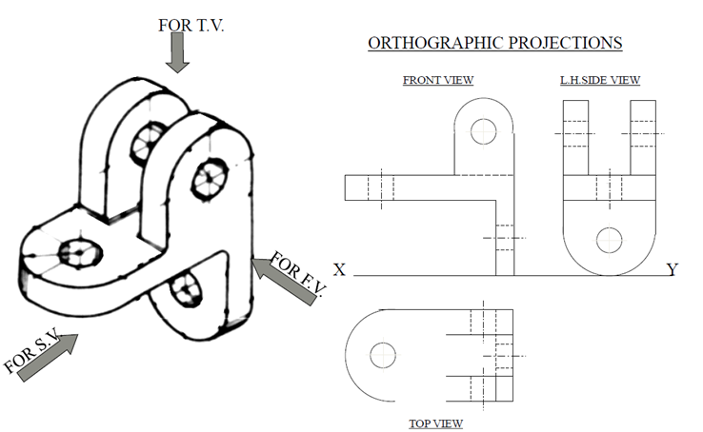

Isometric view of objects:

B5. Draw the isometric view of the object with reference to its orthographic projection.

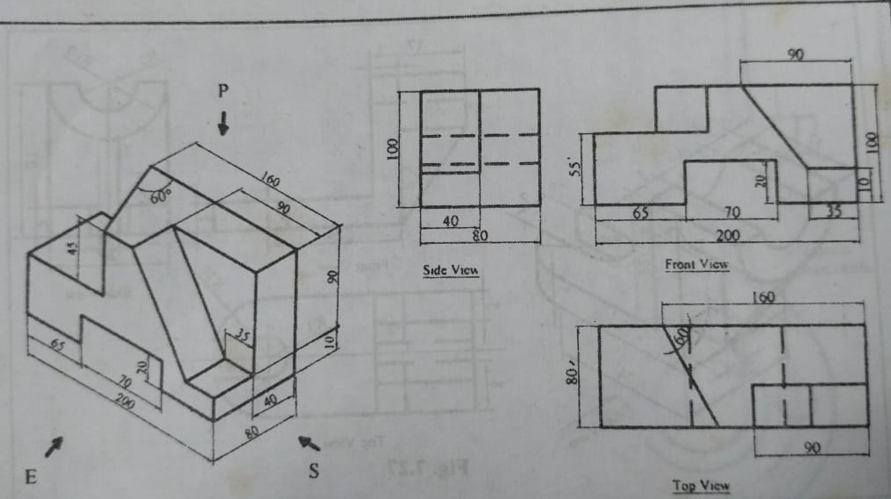

B6. Draw the isometric view of the object with reference to its orthographic projection.

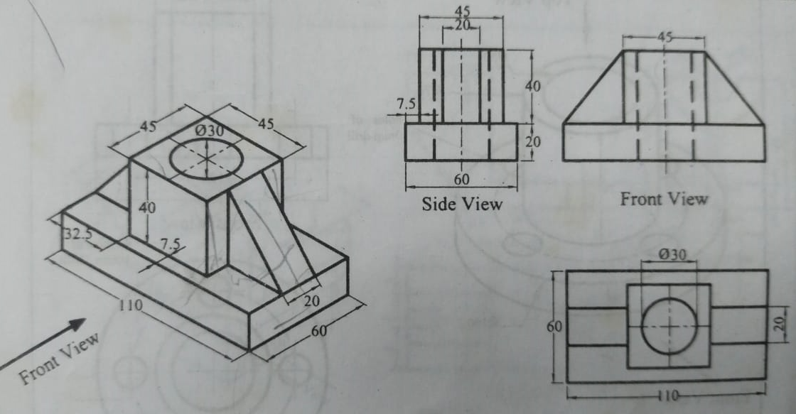

Development of surfaces:

B7. A square pyramid of base side 40 mm and height 75 mm has its base side equally inclined to V.P. It is cut by a plane perpendicular to V.P., 40 degree to H.P. meeting the axis at a distance of 40 mm from the base. Draw the development of the lateral surface of the pyramid.

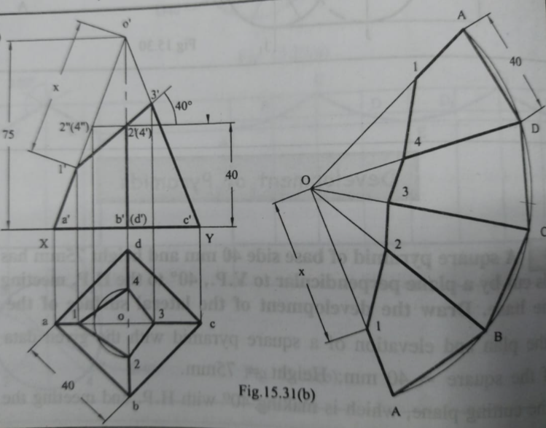

B8. Draw the development of a cylinder of 60 mm diameter and 80 mm height containing a square hole of 30 mm side. The side of the hole are equally inclined to the base axis of the hole bisects the axis of cylinder.

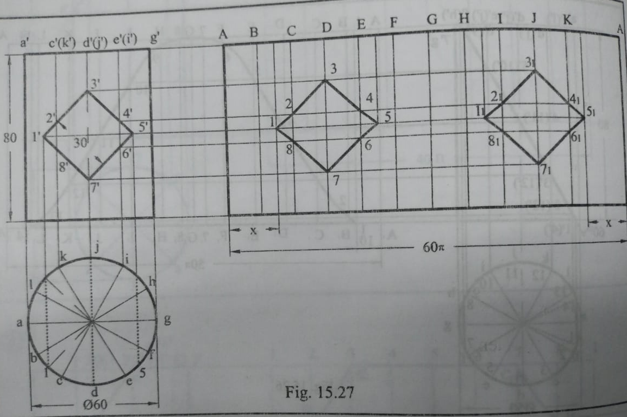

Section of solids:

C1. A hexagonal pyramid, base 30 mm side and axis 70 mm long is resting on its slant edge of the face on the horizontal plane. A section plane, perpendicular to the V.P., inclined to the H.P. passes through the highest corner of the base and intersects the axis at 25 mm from the base. Draw the projections of the solid and determine the inclination of the section plane with the H.P.

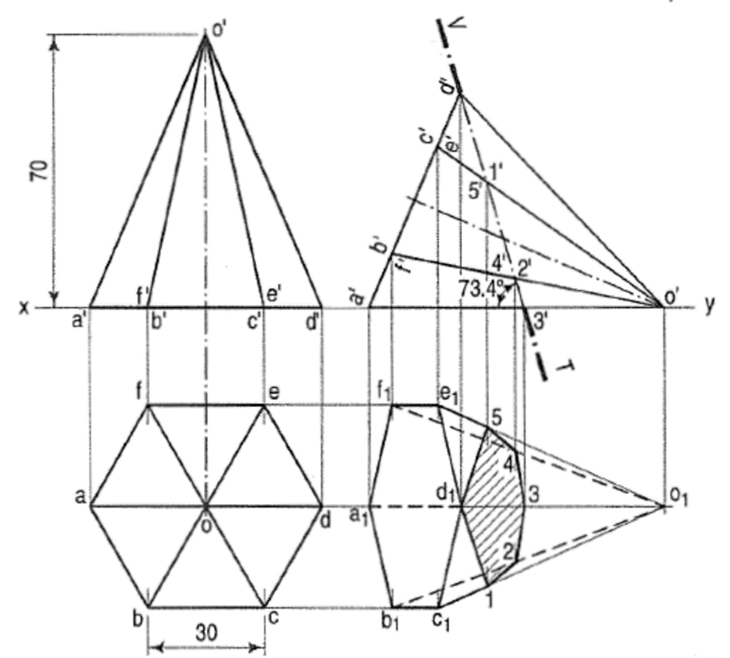

Intersection of solids:

C2. A vertical  cylinder of 75 mm diameter is penetrated by another cylinder of the same size. The axis of the penetrating cylinder is parallel to both the H.P. and the V.P. and is 9 mm away from the axis of the vertical cylinder. Draw the projections showing curves of intersection.

Solids Position

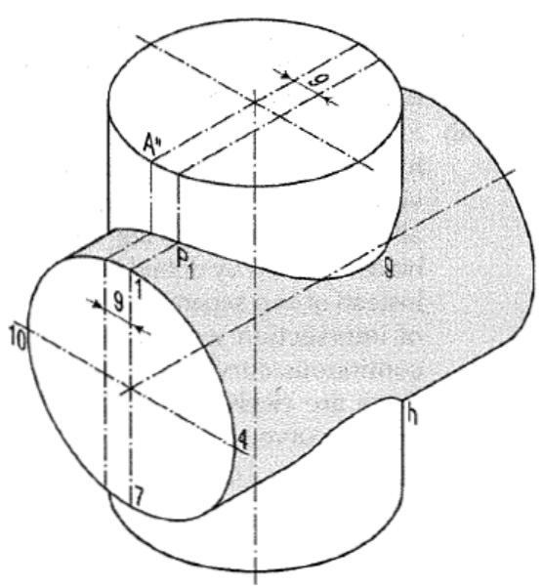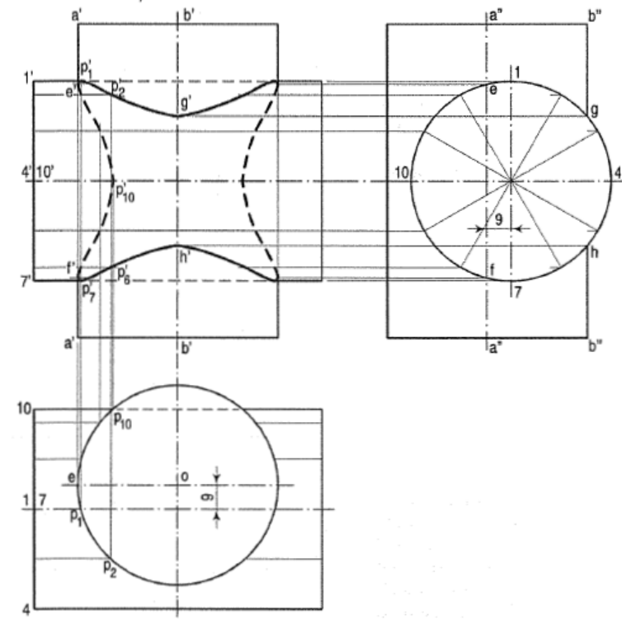Solution

Orthographic projection of objects:

C3. Draw the first angle orthographic projections (front view, top view and left side view) of the object shown below.

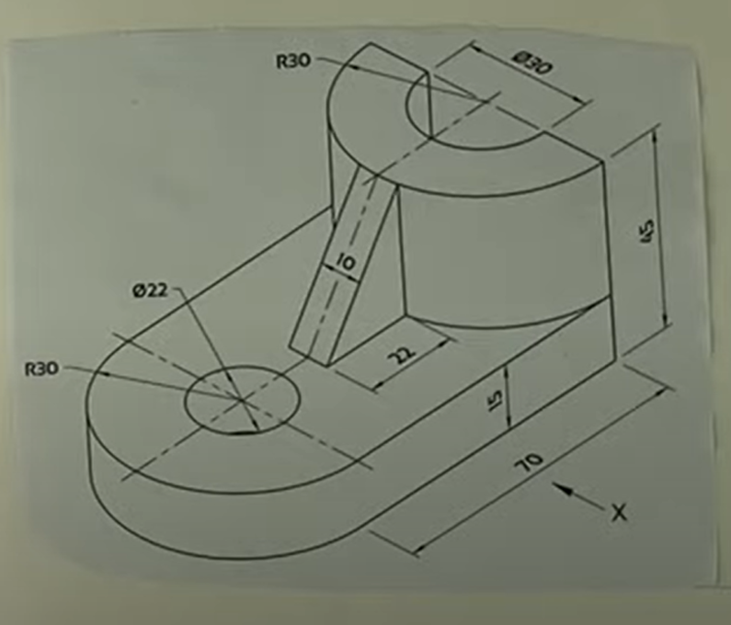

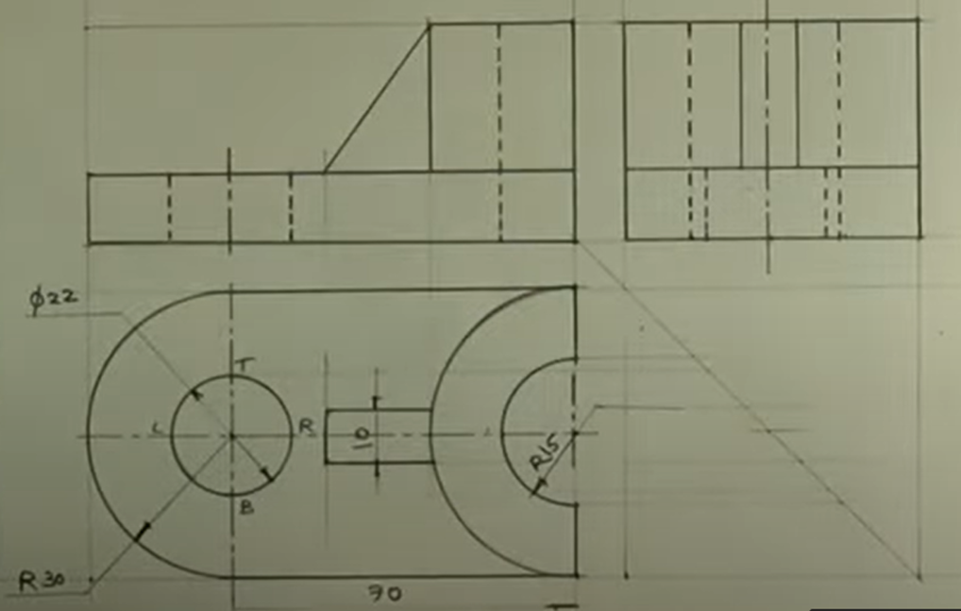

C4. Draw the first angle orthographic projections (front view, top view and right side view) of the object shown below.

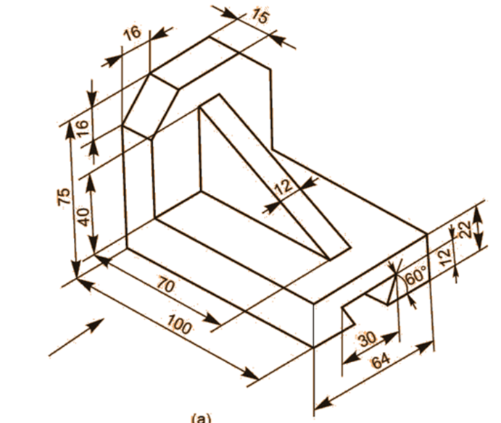

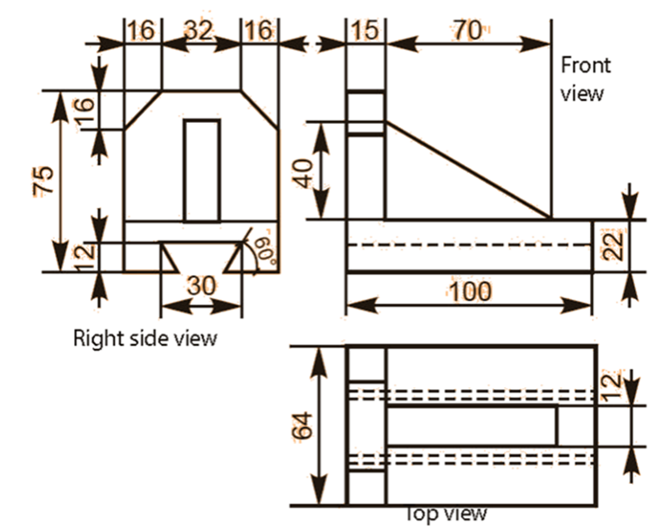

Isometric view of objects:

C5. Draw the isometric view of the object shown below:

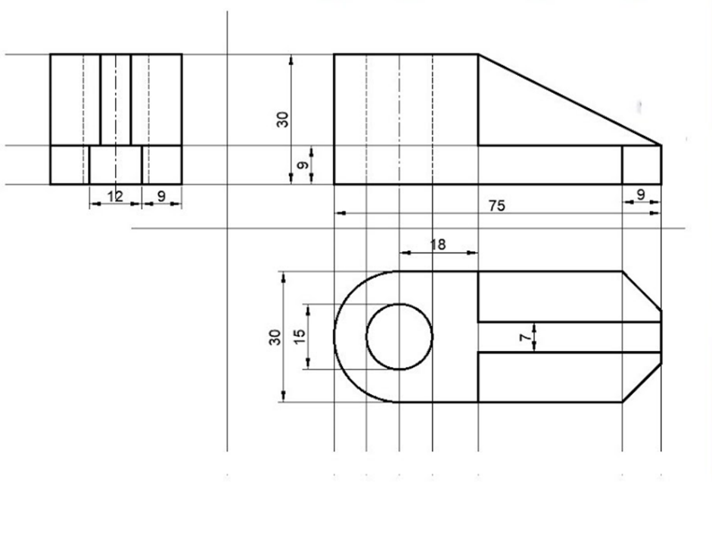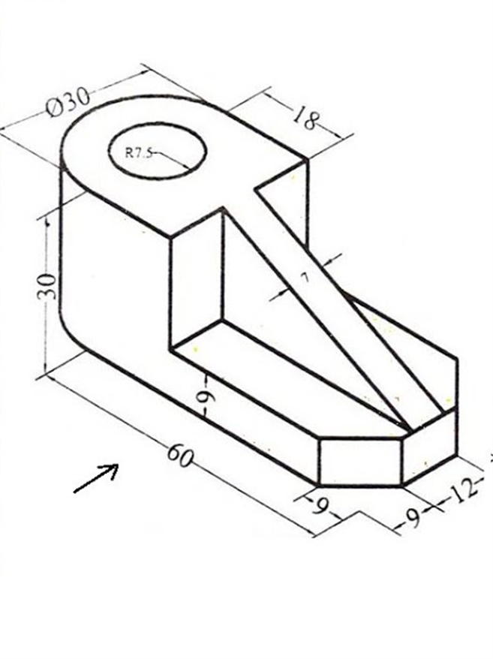

C6. Draw the isometric view of the object shown below:

(dimensioning is not compulsory for this problem)

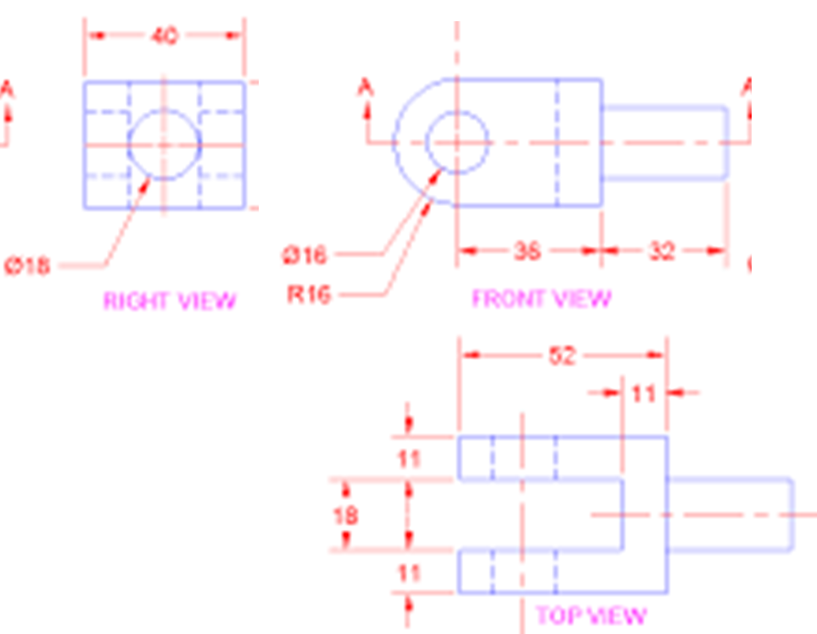

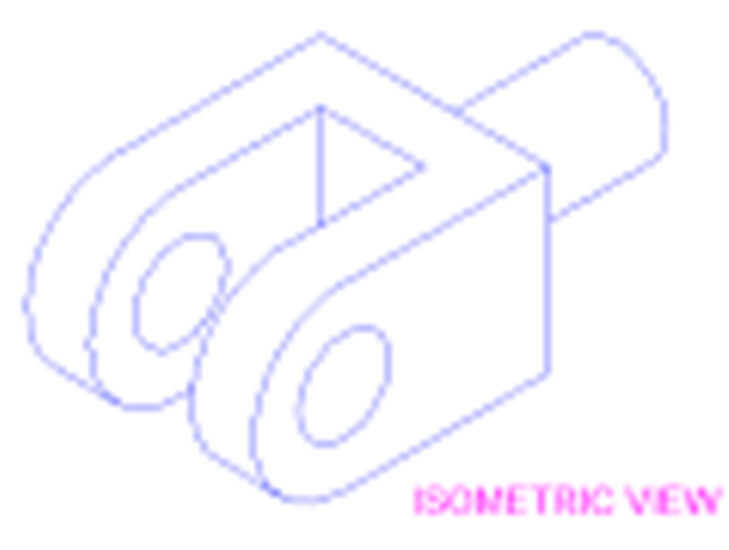

Development of surfaces:

C7. Draw the development of the lateral surface of the solid shown in two views (drawn in first-angle projection) in figure given below.

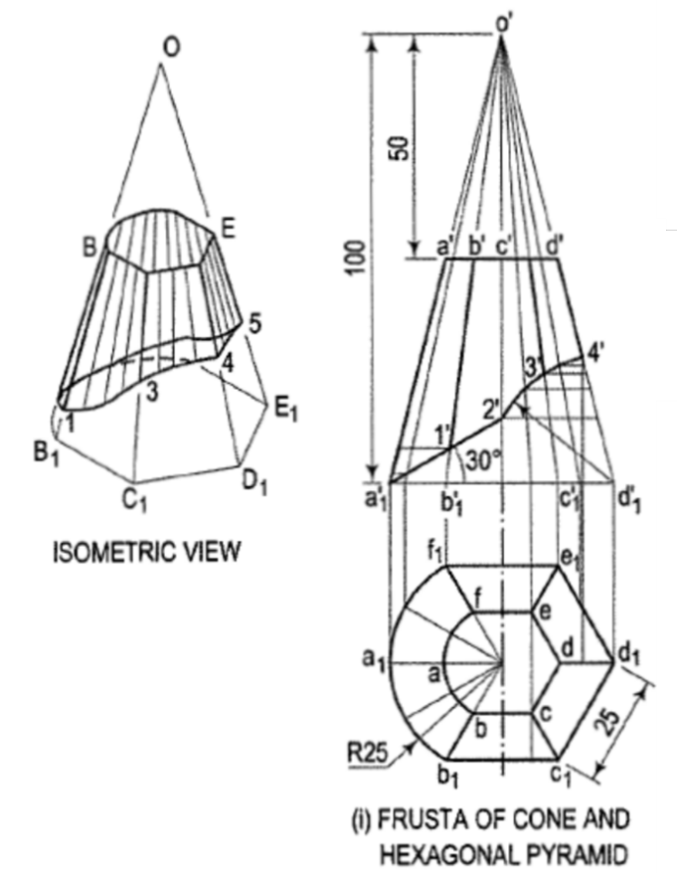

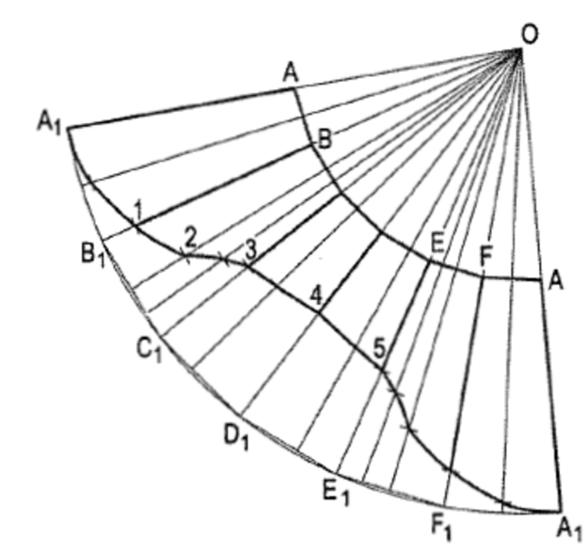

C8. A hexagonal pyramid, base 30 mm side and axis 75 mm long, resting on its base on the HP. with two of its edges parallel to the V.P. is cut by two section planes both perpendicular to the V.P. The horizontal section plane cuts the axis at a point 35 mm from the apex. The other plane which makes an angle of 45° with the HP, also intersects the axis at the same point.

Draw the front view, sectional top view, true shape of the section and development of the surface of the remaining part of the pyramid.

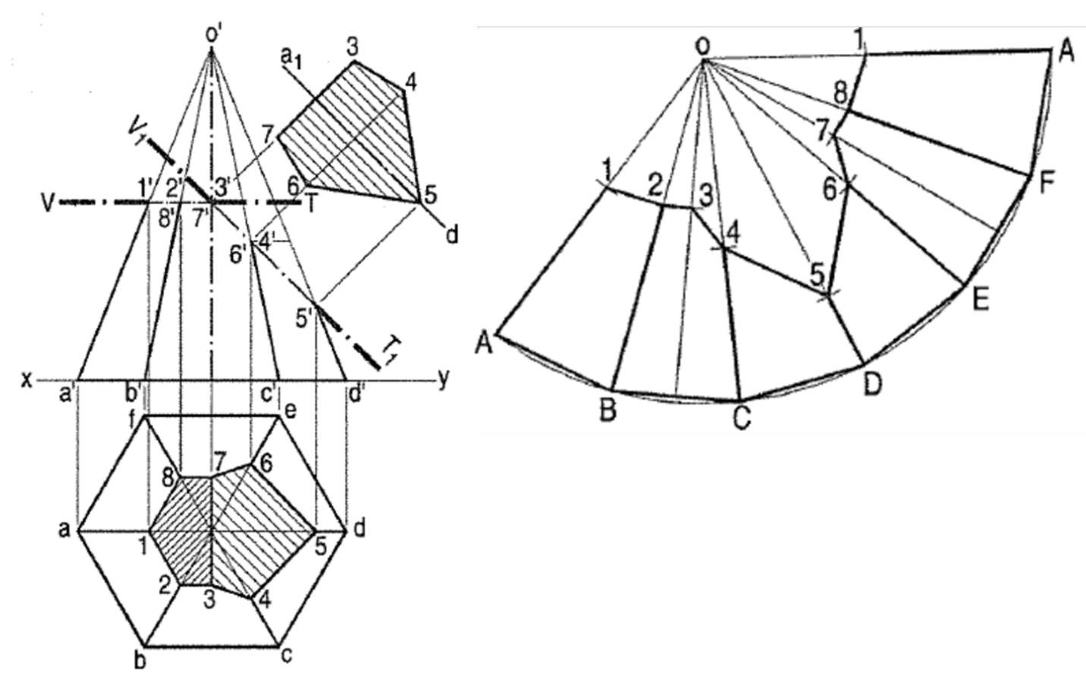

Section of solids:

D1. A triangular prism of side of base 25 and axis 65 long, rests on a corner of the base on H.P., with a base inclined at 60° to H.P. and a rectangular face perpendicular to V.P. A section plane perpendicular to H.P. and inclined at 30° to V.P., bisects the axis of the prism. Draw the projections and determine the true shape of the section.

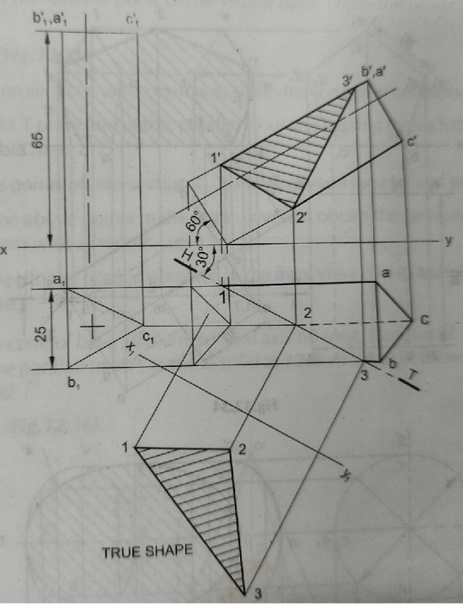

Intersection of solids:

D2. A hexagonal prism with side of base 40, is resting on one of its bases on H.P. with a face parallel to V.P. The prism is penetrated by a square prism of side of base 40. The axis of the square prism is parallel to V.P. and inclined at 30° to H.P., with its faces equally inclined to H.P. Draw the projections, showing lines of intersection when the axis of the square prism is 8 in front of the axis of the hexagonal prism.

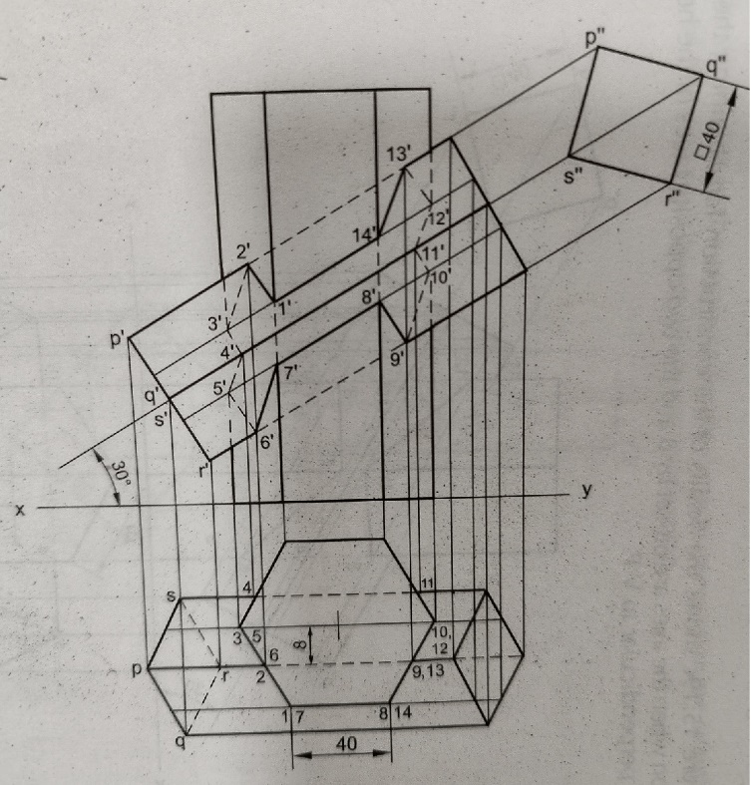

Orthographic projection of objects:

D3. Draw orthographic projections of the given solid.

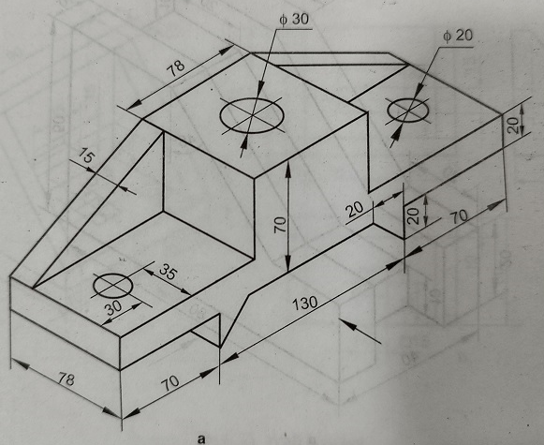 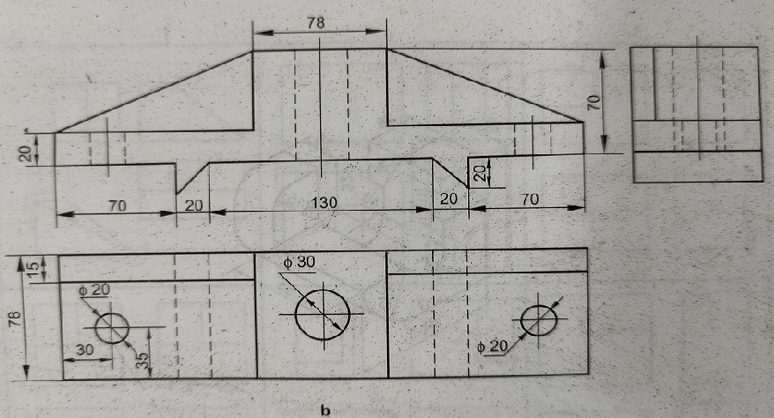

D4. Draw orthographic projections of the given solid.

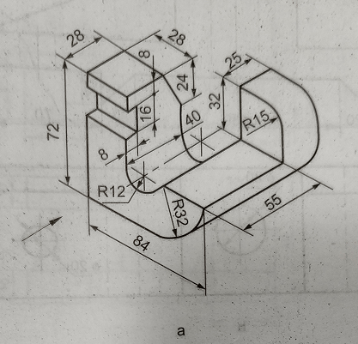

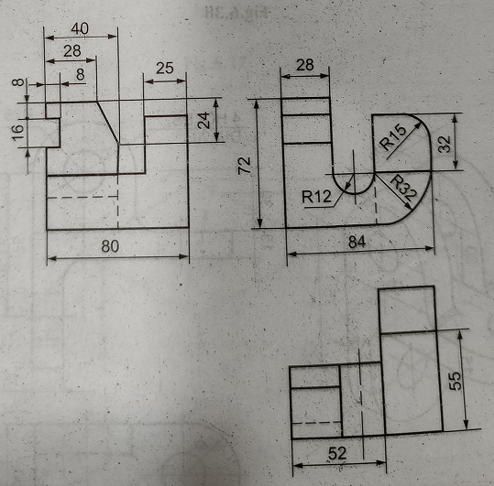

Isometric view of objects:

D5. Draw the isometric view of the solids from its three views

Note: Error of less than 1 unit (mm) can be accepted and fillets shown in the isometric view in not required.

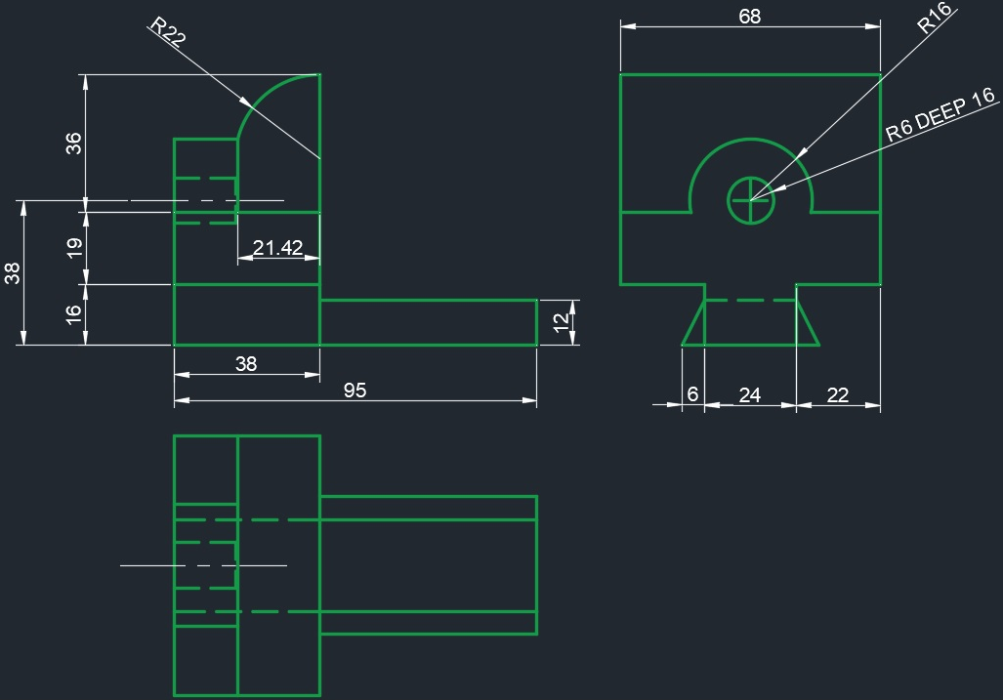

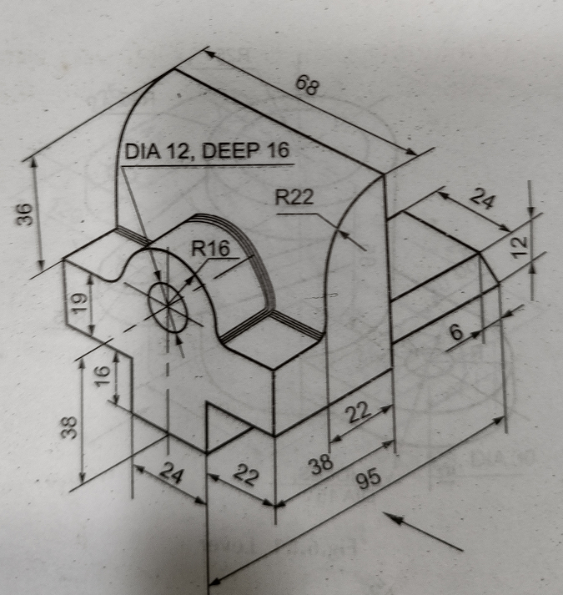

D6. A circular block of 75 diameter and 25 thickness, is pierced centrally through its flat faces by a square prism of base 35 side and 125 long, which comes out equally on both sides of the block. Draw the isometric projection of the combination when the combined axis is horizontal.

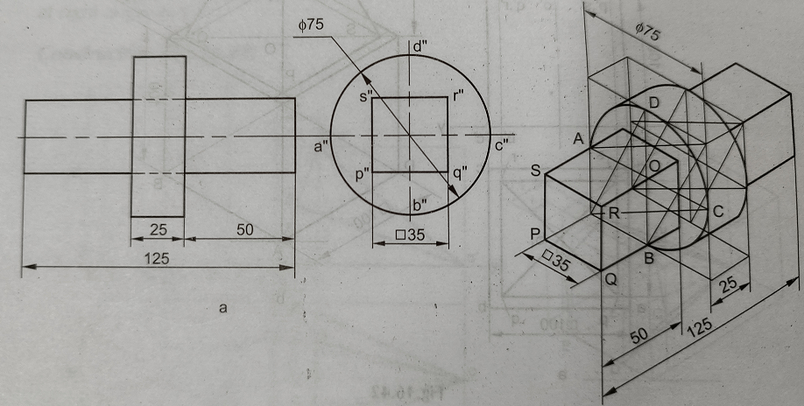

Development of surfaces:

D7. A right circular cone of base diameter 50 and axis 60 long, is resting on its base on H.P. A semi-circular hole of radius 15 is cut through the cone such that, the axis of the hole is perpendicular to V.P. and intersecting the axis of the cone at 20 above the base. The flat surface of the hole is parallel to H.P. Draw the development of the lateral surface of the cone.

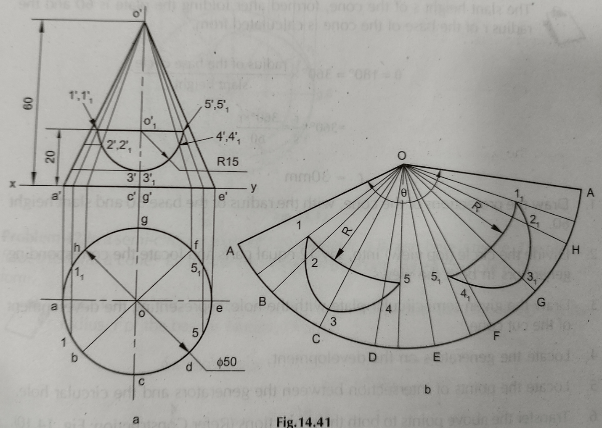

D8. Draw the development of the lateral surface of the oil can, shown in the figure below.

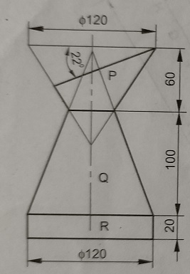

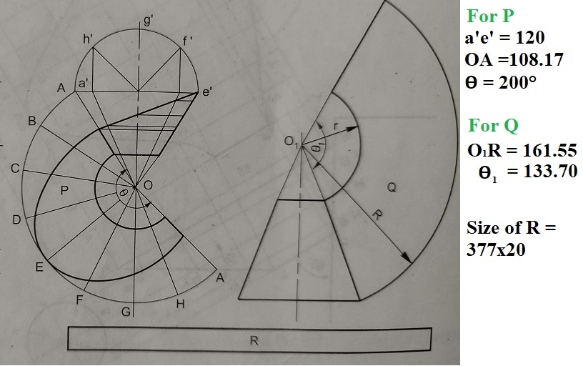

Section of solids:

E1. A hollow cylinder, outside diameter 48 mm, inside diameter 36 mm and height 56 mm, is resting on HP on its base. It is sectioned by a cutting plane to accommodate the maximum possible size of ellipse within it. Draw the sectional views (front, top and side views) and the true shape of the section.  State the lengths (major & minor axis) of the ellipse & the inclination of the section plane.

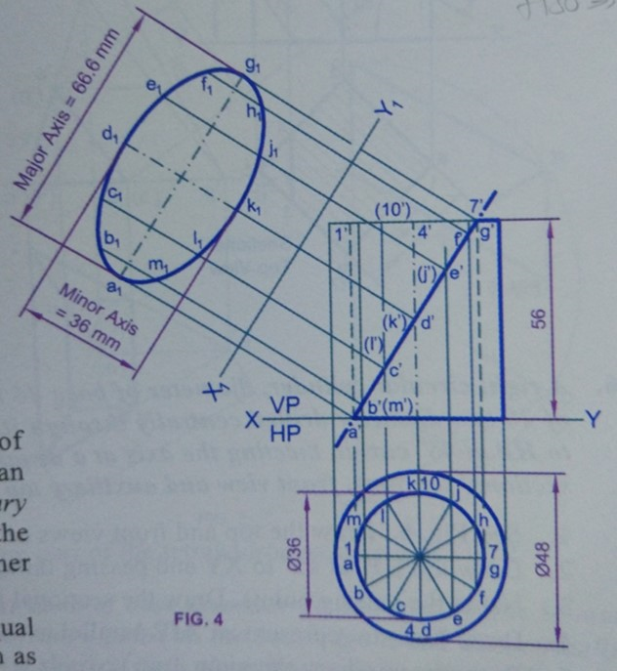

Intersection of solids:

E2. The front view of a cone resting on its base on HP is an equilateral triangle of 75 mm side with one side horizontal. It is penetrated by a square prism of side 25 mm. The rectangular faces of the prism are equally inclined to HP. The axis of the prism is perpendicular to VP and meets that of the cone 25 mm above the base. Draw the three views of the cone showing the curves of intersection.

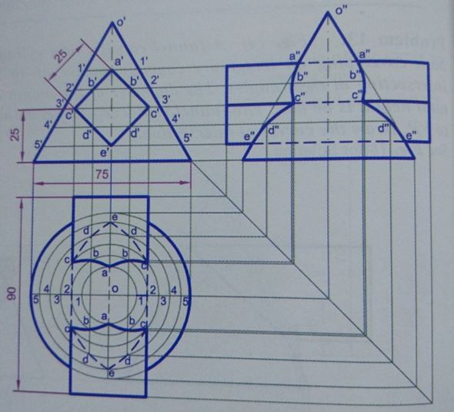

Orthographic projection of objects:

E3. Draw the first-angle orthographic projections (three views) of the object shown below:

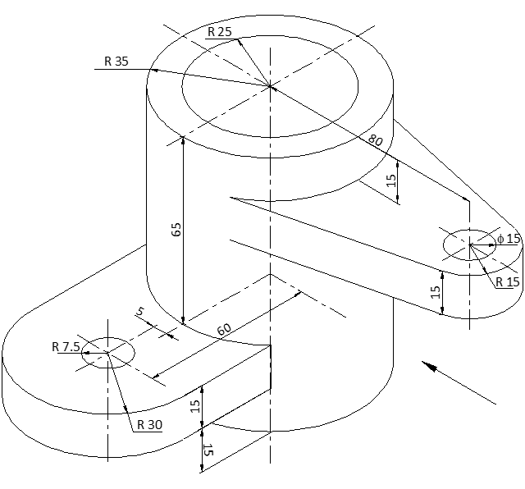

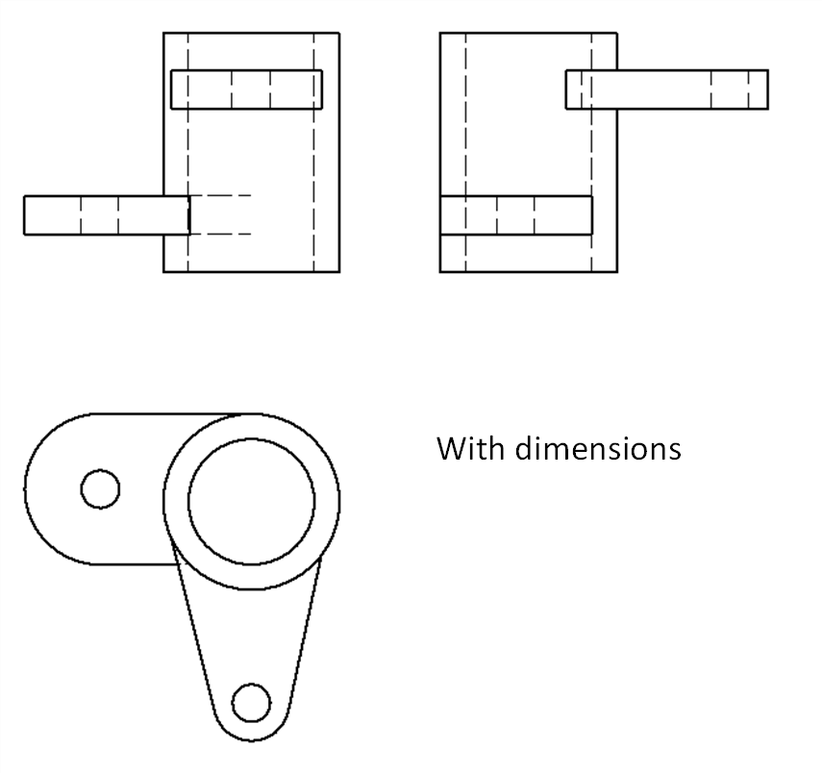

E4. Draw the first-angle orthographic projections (three views) of the object shown below:

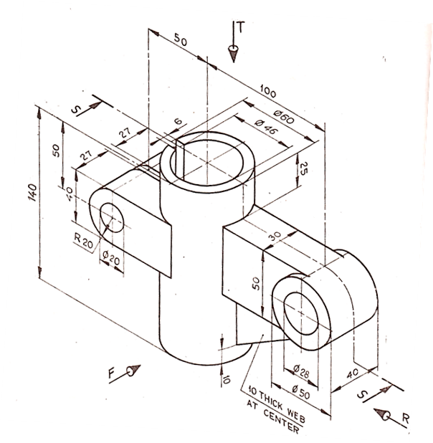

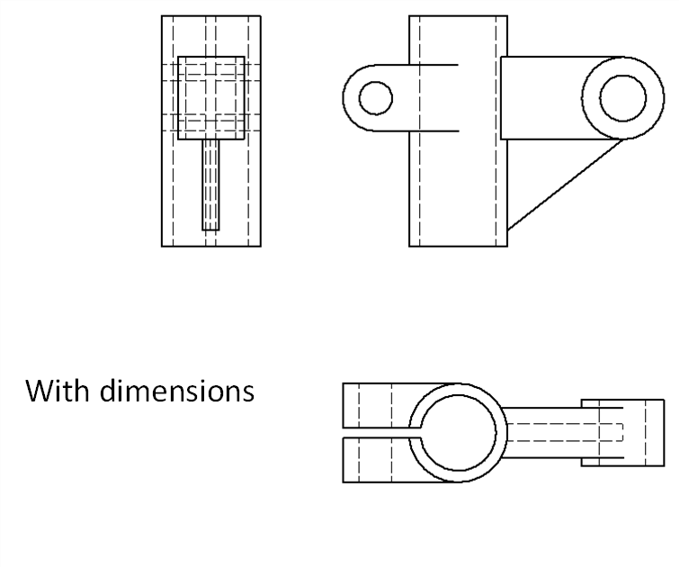

Isometric view of objects:

E5. Draw the isometric view of the object shown below: (Front plane is parallel to YZ)

(dimensioning is not compulsory for this problem)

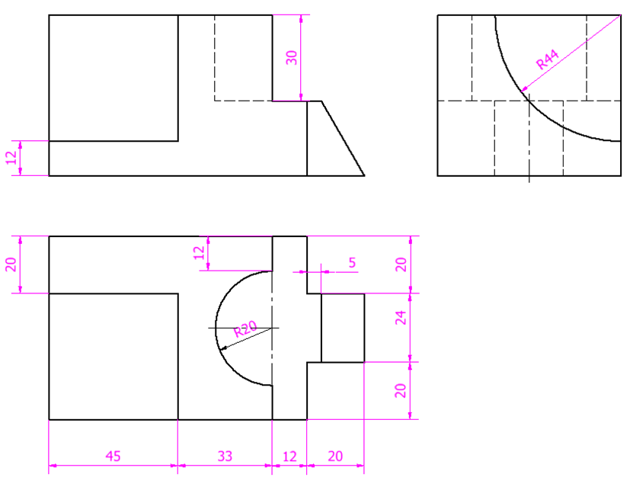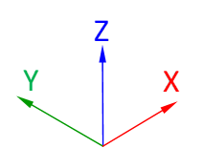

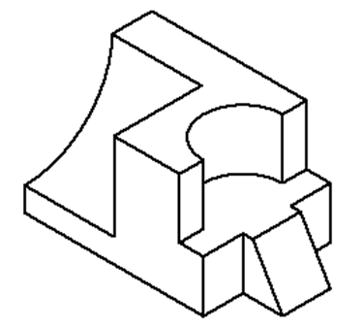

E6. Draw the isometric view of the object shown below: (Front plane is parallel to XZ). (dimensioning is not compulsory for this problem)

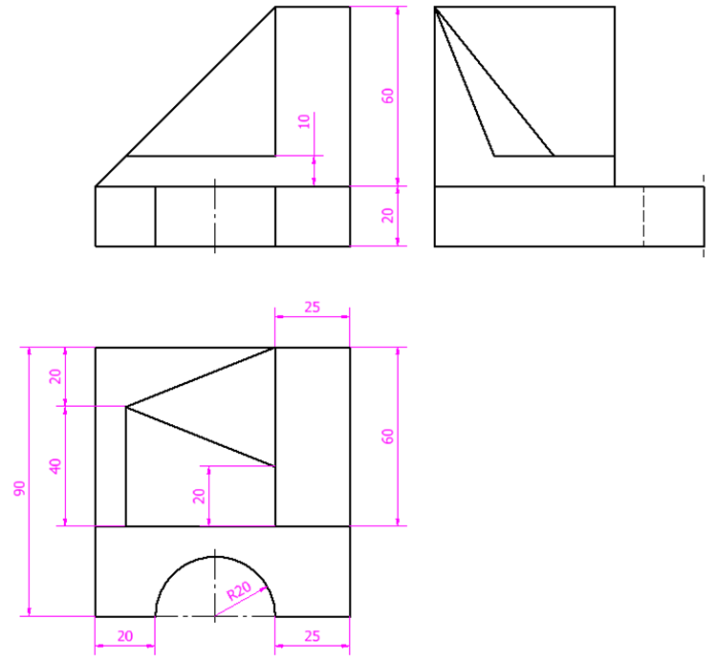

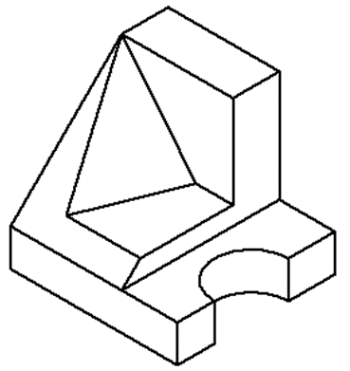

Development of surfaces:

E7. A sugar jar is in the form of a right circular cone of base diameter 60 mm and height 90 mm and it rests on HP. An ant starts moving from the extreme left end of its base, returns to its starting point, after moving around it. Find geometrically the length of the shortest path that ant can take. Show this path in orthographic views.

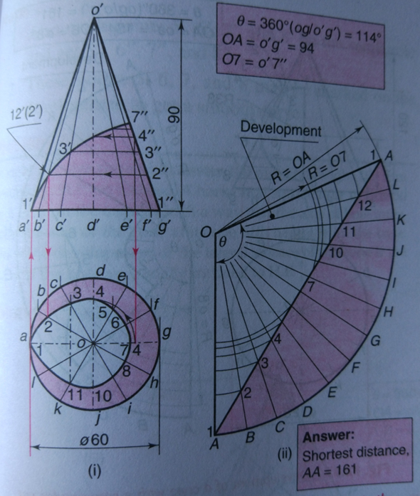

E8. In a semi-circular plate of 100 mm diameter, a largest circular hole is made. The plate is folded to form a cone. Draw the orthographic projections (front, top, and side views) of the cone. Also, find the height of the cone.

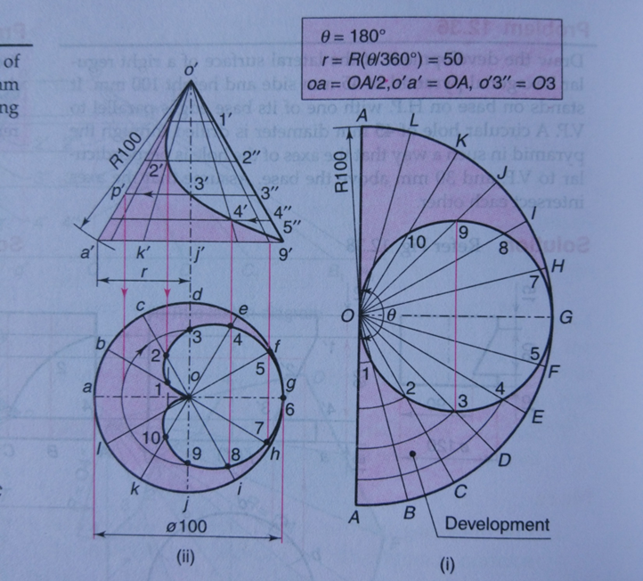

**Question and answers provided by Dr. Rino:**

Section of solids:

F1. A cylinder of diameter 60 mm and height 80 mm has a central hexagonal slot of side 20 mm running right through the length. The cylinder is lying on the HP with its axis perpendicular to the VP. A vertical cutting plane cuts the cylinder in such a way that it meets the bases at 6 mm from diametrically opposite ends. Draw the sectional front view and the true shape of the section.

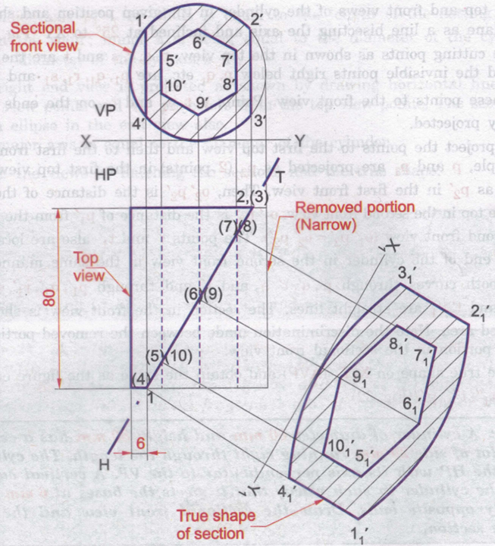

Intersection of solids:

F2. A square pyramid of base sides 50 mm and height 60 mm. The sides of base are equally inclined with the VP. It is penetrated by a horizontal triangular prism of sides 30 mm and 80 mm axis long. The axes of both solids are intersecting each other. The axis of triangular prism is 22 mm above H.P. and perpendicular to the VP. One of faces of triangular prism is perpendicular to the VP. Draw the top view, front view and side view showing the curve of the penetration.

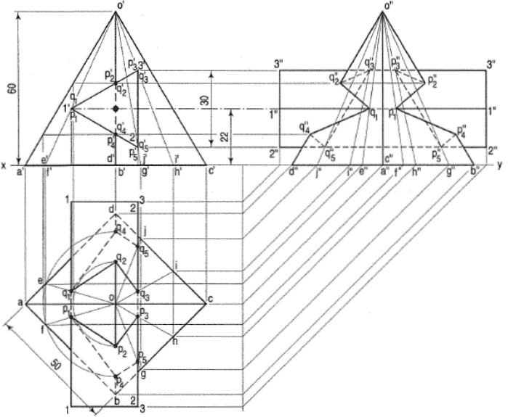

Orthographic projection of objects:

F3. Draw the orthographic projections for the following objects shown in isometric view. Draw the top view, front view and right side view.

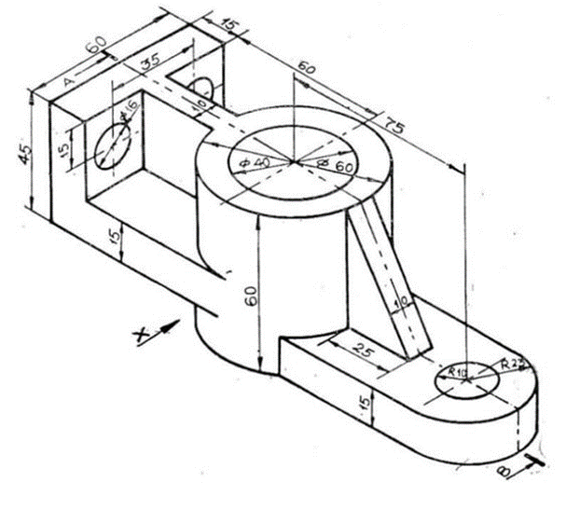

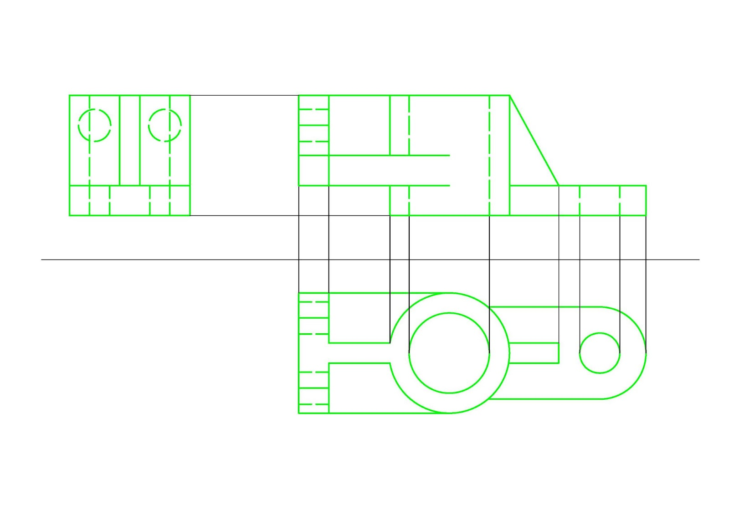

F4. Draw the orthographic projections for the following objects shown in isometric view. Draw the top view, front view and left side view.

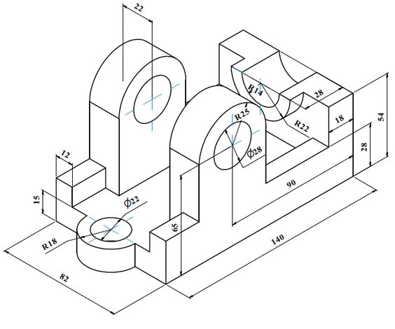

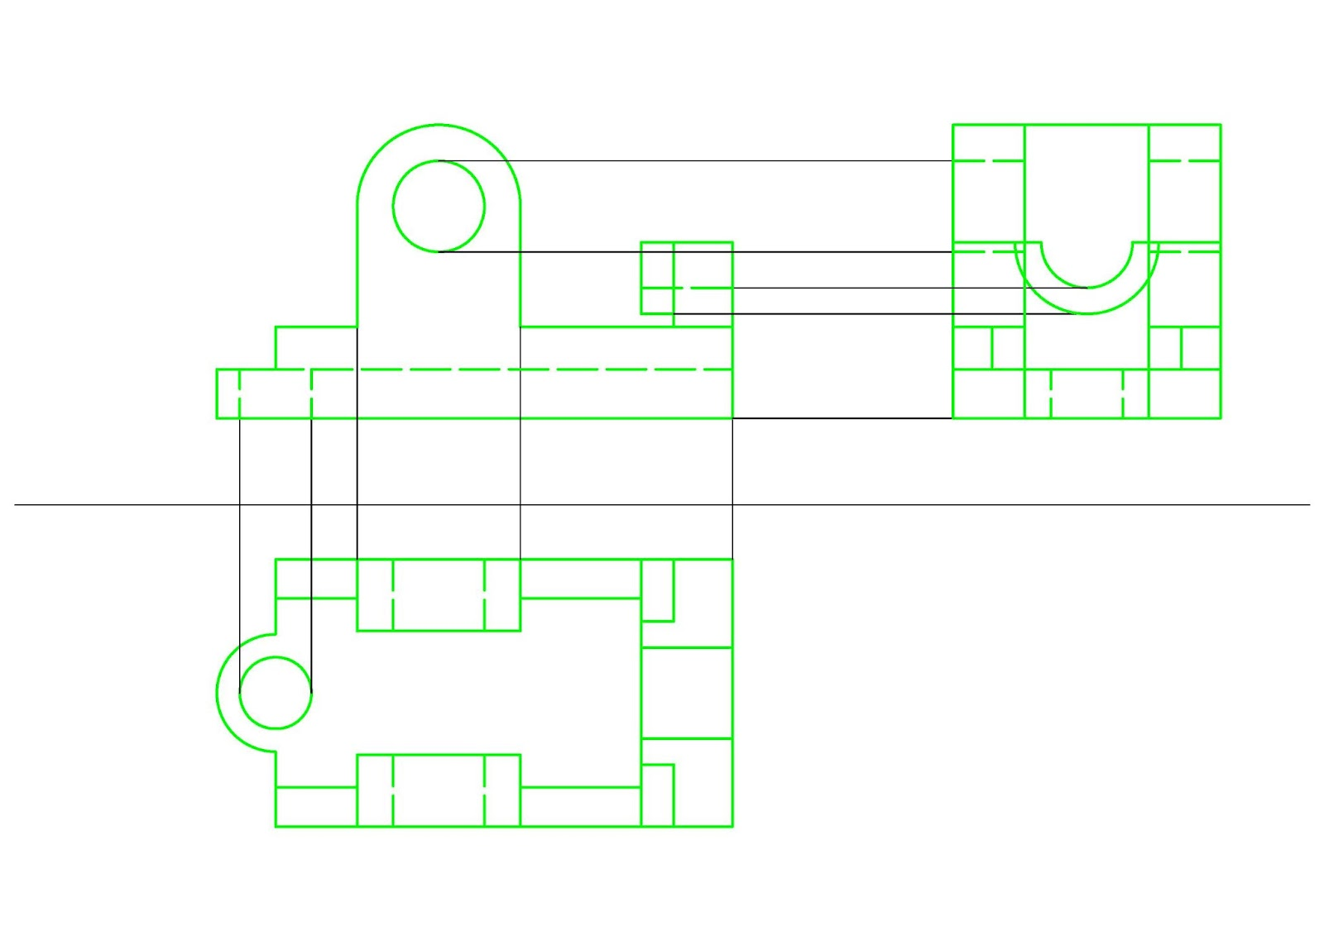

Isometric view of objects:

F5. Draw the isometric view for the following objects whose orthographic projections are given.

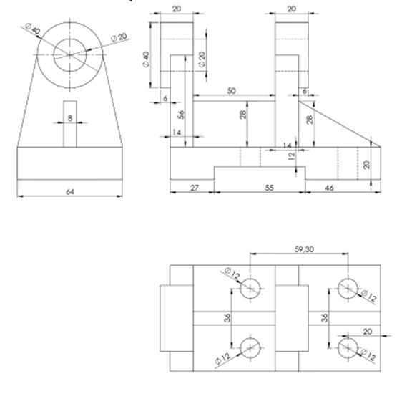

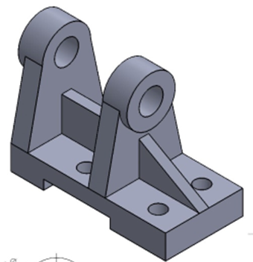

F6. Draw the isometric view for the following objects whose orthographic projections are given.

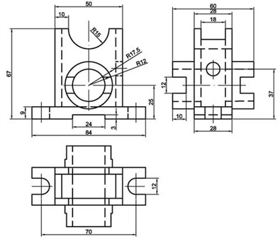

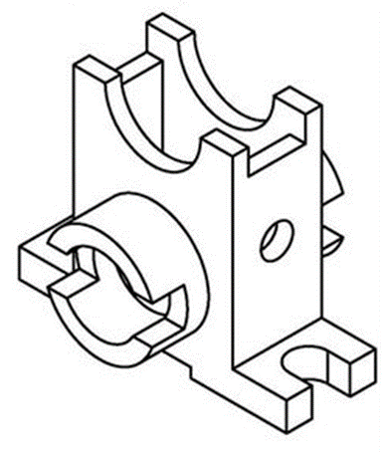

Development of surfaces:

F7. A square pyramid of base side 35 mm and axis 60 mm rests on its base on the ground with one of the sides of the base inclined at 300 to the VP. A string is wound round the surfaces of the pyramid starting from left extreme point on the base and ending at the same point. Find the shortest length of the string required. Also trace the path of the string in the front and top views.

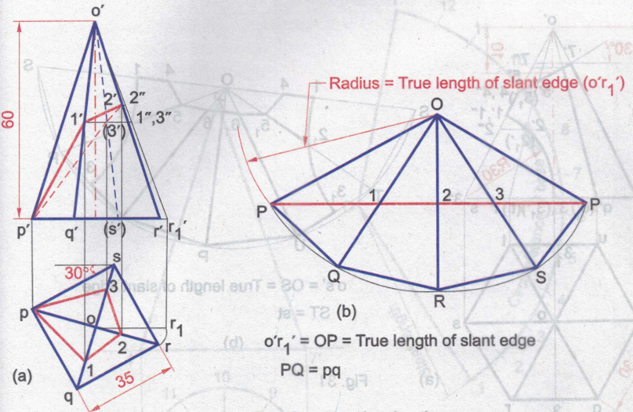

F8. Draw the development of the three pipes forming a Y-piece as shown in Fig. All the pipes are of diameter 40 mm. The maximum height of the vertical pipe is 50 mm. The angle between the axes of the inclined pipes is 800.

